**Hotel Management System**

**by Rahil Sharma**

**Synopsis:**

* This software project is developed to automate the functionalities of a Hotel. It is a form of electronic commerce whereby customer can book rooms and decide his/her hotel booking over the internet.
* Customers are attracted to online booking rooms not only because of the broader selection but also because of greater access to information.
* This project is based upon hotel management, wherein it allows the user to book rooms, type of room of his/her choice and select the particular dates he needs it on. The user then selects his/her choice of room and enters his/her payment details to complete the booking process.
* the principle goal of this package is to ensure that the entire hotel management scheme, like room actions,assigning rooms, admission of a new customer etc is automated and digitized.
* our project includes the features mentioned below:

1. room type selection
2. room number information
3. billing and payment
4. feedback

SOFTWARE SPECIFICATIONS:

**SOFTWARE SPECIFIATIONS**

PLATFORM WINDOWS 10

FRONT END NETBEANS IDE 6

BACK END  MYSQL

**NETBEANS IDE 6.5.1(JAVA)**

The hardest part of building a software system is deciding precisely what to build. NetBeans refers to both a platform framework for java desktop applications, and an Integrated Development Environment(IDE) for developing with Java,Javascript,PHP and others.

The NetBeans IDE is written in java and runs everywhere where a JVM is installed, including Windows , MAC OS, Linux, and Solaris. A JDK is required for development in other programming languages.

Netbeans is the front end tool.

**MYSQL:**

MYSQL is a Relational Database Management System(RDBMS) that runs as a server providing multi user access to a number of databases. MYSQL is officially pronounced (“MY S-Q-L”).

It is named after developer Michael Widenius , MY. The SQL phrase stands for Structured Query Language.The MYSQL development project has made its source code available under the terms of GNU General Public License, as under a variety of proprietary agreements. MYSQL is now owned by Oracle Corporation.Free-Software projects that require a full-featured database management system often use MYSQL. Such projects include LAMP software stack.

## MySQL is the back-end tool.

**Table Structure and Database:**

Create database if not exists resort;

Use resort;

* FOR TABLE ROOM:

Create table ROOM(

Roomno int(11) primary key,

Type code varchar(22));

Insert into mariot values(001,”SN”);

Insert into marriot values(002,”SL”);

Insert into marriot values(003,”DM”);

Insert into marriot values(004,”DL”);

* FOR TABLE BOOKING:

Create table booking(

Bookingno int(11) primary key,

CustName varchar(20),

Address varchar(30),

Sex varchar(1),

Age int(11),

Roomno int(11),

Fromd date,

Tod date,

Advance int(11),

Total int(11));

Insert into booking values(10,”Natasha”,”Hyderabad”,”F”,21,001,”2010-12-15”,”2010-12-31”,2000,20000);

Insert into booking values(11,”Disha”,”Hyderabad”,”F”,22,002,”2011-12-15”,”2011-12-31”,2000,40000);

Insert into booking values(13,”Sumreen”,”Hyderabad”,”F”,23,003,”2012-12-15”,”2012-12-31”,2000,60000);

Insert into booking values(14,”Veronica”,”Hyderabad”,”F”,24,003,”2010-02-30”,”2010-03-15”,2000,80000);

* FOR TABLE TYPE:

CREATE TABLE TYPE(

Typecode char(2) primary key,

Description varchar(30),

Charges int(11));

Insert into type values(“SN”,”SINGLE BED NON AC”,4000);

Insert into type values(“SL”,”SINGLE BED AC”,8000);

Insert into type values(“DM”,”DOUBLE BED NON AC”,6000);

Insert into type values(“DL”,”DOUBLE BED AC”,10000);

* FOR STATUS1…..STATUS4(4 TABLES FOR STORING STATUS OF 4 ROOMS)

CREATE TABLE STATUS1(

ROOMNO INT(11),

Type code char(20),

D1 char(1),

D2 char(1),

D3 char(1),

D4 char(1));

Insert into status1 values (001,”SL”,”YES”,”NO”,”NO”,”NO”);

Insert into status1 values (002,”SN”,”NO”,”YES”,”NO”,”NO”);

Insert into status values (003,”DM”,”NO”,”NO”,”YES”,”NO”);

Insert into status1 values (004,”DL”,”NO”,”NO”,”NO”,”YES”);

* DO THE SAME FOR STATUS2,STATUS3,STATUS4 tables.
* Table structure: room

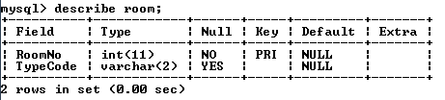

* Table structure: booking

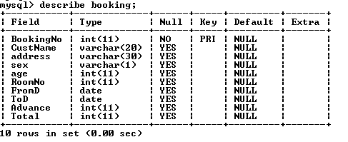

* Table structure type:

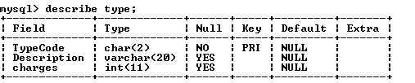

program codes:

CODE FOR FRAME 1:

Code:

public class MainMenu extends javax.swing.JFrame {

/** Creates new form MainMenu */

public MainMenu() {

initComponents();

}

private void jButton2ActionPerformed(java.awt.event.ActionEvent evt) {

// TODO add your handling code here:

RPMenu rp = new RPMenu();

rp.setVisible(true);

this.setVisible(false);

}

private void jButton3ActionPerformed(java.awt.event.ActionEvent evt) {

// TODO add your handling code here:

BookCancel bc = new BookCancel();

bc.setVisible(true);

this.setVisible(false);

}

private void jButton4ActionPerformed(java.awt.event.ActionEvent evt) {

// TODO add your handling code here:

Report rp = new Report();

rp.setVisible(true);

this.setVisible(false);

}

private void jButton5ActionPerformed(java.awt.event.ActionEvent evt) {

// TODO add your handling code here:

System.exit(0);

}

private void jButton6ActionPerformed(java.awt.event.ActionEvent evt) {

// TODO add your handling code here:

AboutMe.setVisible(false);

}

private void jButton1ActionPerformed(java.awt.event.ActionEvent evt) {

// TODO add your handling code here:

AboutMe.setVisible(true);

}

public static void main(String args[]) {

java.awt.EventQueue.invokeLater(new Runnable() {

public void run() {

new MainMenu().setVisible(true);

}

});}

**CODE FOR FRAME 2:**

import java.awt.Container;

import java.sql.*;

public class RPMenu extends javax.swing.JFrame {

/** Creates new form RPMenu */

public RPMenu() {

initComponents();

EnterRoomDetailsPanel.setVisible(false);

EnterRoomNoPanel.setVisible(false);

EnterNewChargesPanel.setVisible(false);

RoomProcessingOptionsPanel.setVisible(true);

}

private void AddBActionPerformed(java.awt.event.ActionEvent evt) {

// TODO add your handling code here:

error.setText(" ");

String Rnum = RNumTF.getText();

String Tcode = TCode.getSelectedItem().toString();

try

{

Class.forName("java.sql.Driver");

String database = "jdbc:mysql://localhost:3306/Hotal";

Connection conn = DriverManager.getConnection(database, "root", "pace");

Statement stmt = conn.createStatement();

String sql = "Insert into Room values ( '" + Rnum + "','" + Tcode + "')" ;

stmt.executeUpdate(sql);

for(int i=1; i<13;i++)

{

String sql2 = "Insert into Status" + i + "(RoomNo, TypeCode) values ( '" + Rnum + "','" + Tcode + "')" ;

Statement stmt2 = conn.createStatement();

stmt2.executeUpdate(sql2);

}

error.setText("Information added");

stmt.close();

conn.close();

}

catch (Exception e) { error.setText("Incorrect Entry");}

}

private void TCode2ItemStateChanged(java.awt.event.ItemEvent evt) {

// TODO add your handling code here:

String code = TCode2.getSelectedItem().toString();

try

{

Class.forName("java.sql.Driver");

String database = "jdbc:mysql://localhost:3306/Hotal";

Connection conn = DriverManager.getConnection(database, "root", "pace");

Statement stmt = conn.createStatement();

String sql = "select Charges from Type where TypeCode = '" + code + "'";

ResultSet rs = stmt.executeQuery(sql);

rs.next();

int str = rs.getInt("Charges");

rs.close();

stmt.close();

conn.close();

curCharges.setText("Rs " + str);

} catch (Exception e) { }

}

private void ChangeBActionPerformed(java.awt.event.ActionEvent evt) {

// TODO add your handling code here:

String code = TCode2.getSelectedItem().toString();

int charges =Integer.parseInt( ChargesTF.getText());

try

{

Class.forName("java.sql.Driver");

String database = "jdbc:mysql://localhost:3306/Hotal";

Connection conn = DriverManager.getConnection(database, "root", "pace");

Statement stmt = conn.createStatement();

String sql = "update Type set Charges = " + charges + " where TypeCode = '" + code + "'" ;

stmt.executeUpdate(sql);

stmt.close();

conn.close();

error1.setText("Information added");

} catch (Exception e) { error1.setText("Invalid Data");}

}

private void SearchBActionPerformed(java.awt.event.ActionEvent evt) {

// TODO add your handling code here:

int rnum =Integer.parseInt(RNoTF.getText());

try

{

Class.forName("java.sql.Driver");

String database = "jdbc:mysql://localhost:3306/Hotal";

Connection conn = DriverManager.getConnection(database, "root", "pace");

Statement stmt = conn.createStatement();

String sql = "select Type.TypeCode, Description, Charges from Type , Room where RoomNo = " + rnum + " and Type.TypeCode = Room.TypeCode";

ResultSet rs = stmt.executeQuery(sql);

rs.next();

String str = rs.getString("TypeCode");

roomDetailsTA.setText(str);

String str1 = rs.getString("Description");

String str2 = rs.getString("Charges");

roomDetailsTA.setText("Room Number :" + rnum + "\nType: " + str + "\nDescription: " + str1 + "\nCharges : " + str2);

rs.close();

stmt.close();

conn.close();

} catch (Exception e) { error2.setText("Room Number Not Found");}

}

private void BackActionPerformed(java.awt.event.ActionEvent evt) {

// TODO add your handling code here:

MainMenu m = new MainMenu();

m.setVisible(true);

this.setVisible(false);

}

private void NewRoomBActionPerformed(java.awt.event.ActionEvent evt) {

EnterNewChargesPanel.setVisible(false);

RoomProcessingOptionsPanel.setVisible(false);

EnterRoomNoPanel.setVisible(false);

EnterRoomDetailsPanel.setVisible(true);

}

private void CChargesBActionPerformed(java.awt.event.ActionEvent evt) {

EnterRoomDetailsPanel.setVisible(false);

RoomProcessingOptionsPanel.setVisible(false);

EnterRoomNoPanel.setVisible(false);

EnterNewChargesPanel.setVisible(true);

}

private void RDetailsBActionPerformed(java.awt.event.ActionEvent evt) {

EnterRoomDetailsPanel.setVisible(false);

EnterNewChargesPanel.setVisible(false);

RoomProcessingOptionsPanel.setVisible(false);

EnterRoomNoPanel.setVisible(true);

}

private void back2MainMItemActionPerformed(java.awt.event.ActionEvent evt) {

// TODO add your handling code here:

MainMenu m = new MainMenu();

m.setVisible(true);

this.setVisible(false);

}

private void logoutMItemActionPerformed(java.awt.event.ActionEvent evt) {

// TODO add your handling code here:

//new login().setVisible(true);

this.setVisible(false);

}

private void AddRoomMItemActionPerformed(java.awt.event.ActionEvent evt) {

EnterNewChargesPanel.setVisible(false);

RoomProcessingOptionsPanel.setVisible(false);

EnterRoomNoPanel.setVisible(false);

EnterRoomDetailsPanel.setVisible(true);

}

private void ChangeChargesMItemActionPerformed(java.awt.event.ActionEvent evt) {

EnterRoomDetailsPanel.setVisible(false);

RoomProcessingOptionsPanel.setVisible(false);

EnterRoomNoPanel.setVisible(false);

EnterNewChargesPanel.setVisible(true);

}

private void RoomDetailsMItemActionPerformed(java.awt.event.ActionEvent evt) {

EnterRoomDetailsPanel.setVisible(false);

EnterNewChargesPanel.setVisible(false);

RoomProcessingOptionsPanel.setVisible(false);

EnterRoomNoPanel.setVisible(true);

}

**CODE FOR FRAME 3:**

import java.sql.*;

import javax.swing.JOptionPane;

public class Report extends javax.swing.JFrame {

/** Creates new form Report */

public Report() {

initComponents();

Entry4ResStatusPanel.setVisible(false);

Entry4BillPanel.setVisible(false);

Entry4ResSlipPanel.setVisible(false);

ReportingOptionsPanel.setVisible(true);

}

private void SearchBTNActionPerformed(java.awt.event.ActionEvent evt) {

// TODO add your handling code here:

int month = Integer.parseInt(MonthCB.getSelectedItem().toString());

new Status(month).setVisible(true);

//this.setVisible(false);

}

private boolean search(int bno)

{

try {

Class.forName("java.sql.Driver");

String database = "jdbc:mysql://localhost:3306/Hotal";

Connection conn = DriverManager.getConnection(database, "root", "pace");

Statement stmt = conn.createStatement();

String sql = "select * from Booking where BookingNo = " + bno;

ResultSet rs = stmt.executeQuery(sql);

if(rs.next())

{

return true;

}

else

{

return false;

}

} catch (Exception e) { JOptionPane.showMessageDialog(null,"" + e);

return false; }

}

private void GenerateResSlipBTNActionPerformed(java.awt.event.ActionEvent evt) {

// TODO add your handling code here:

int bno = Integer.parseInt( BokingNo4ResSlipTF.getText());

if(search(bno))

{

new ReservaTionSlip(bno).setVisible(true);

this.setVisible(false);

}

else

{

error1.setText("Unable to fine Booking number");

}

}

private void BackActionPerformed(java.awt.event.ActionEvent evt) {

// TODO add your handling code here:

MainMenu m = new MainMenu();

m.setVisible(true);

this.setVisible(false);

}

private void StatusBTNActionPerformed(java.awt.event.ActionEvent evt) {

// TODO add your handling code here:

Entry4ResSlipPanel.setVisible(false);

Entry4BillPanel.setVisible(false);

ReportingOptionsPanel.setVisible(false);

Entry4ResStatusPanel.setVisible(true);

}

private void RSlipBTNActionPerformed(java.awt.event.ActionEvent evt) {

// TODO add your handling code here:

Entry4ResStatusPanel.setVisible(false);

Entry4BillPanel.setVisible(false);

ReportingOptionsPanel.setVisible(false);

Entry4ResSlipPanel.setVisible(true);

}

private void BillBTNActionPerformed(java.awt.event.ActionEvent evt) {

// TODO add your handling code here:

Entry4ResStatusPanel.setVisible(false);

ReportingOptionsPanel.setVisible(false);

Entry4ResSlipPanel.setVisible(false);

Entry4BillPanel.setVisible(true);

}

private void GenerateBillBTNActionPerformed(java.awt.event.ActionEvent evt) {

// TODO add your handling code here:

int bno = Integer.parseInt( BokingNo4BillTF.getText());

if(search(bno))

{

new Bill(bno).setVisible(true);

this.setVisible(false);

}

else

{

error2.setText("Unable to fine Booking number");

}

}

private void back_MainMenuMItemActionPerformed(java.awt.event.ActionEvent evt) {

// TODO add your handling code here:

MainMenu m = new MainMenu();

m.setVisible(true);

this.setVisible(false);

}

private void back_LogoutMItemActionPerformed(java.awt.event.ActionEvent evt) {

// TODO add your handling code here:

//new login().setVisible(true);

this.setVisible(false);

}

private void view_StatusMItemActionPerformed(java.awt.event.ActionEvent evt) {

Entry4ResSlipPanel.setVisible(false);

Entry4BillPanel.setVisible(false);

ReportingOptionsPanel.setVisible(false);

Entry4ResStatusPanel.setVisible(true);

}

private void view_ResSlipMItemActionPerformed(java.awt.event.ActionEvent evt) {

Entry4ResStatusPanel.setVisible(false);

ReportingOptionsPanel.setVisible(false);

Entry4BillPanel.setVisible(false);

Entry4ResSlipPanel.setVisible(true);

}

private void view_BillMItemActionPerformed(java.awt.event.ActionEvent evt) {

Entry4ResStatusPanel.setVisible(false);

ReportingOptionsPanel.setVisible(false);

Entry4ResSlipPanel.setVisible(false);

Entry4BillPanel.setVisible(true);

}

private void BokingNo4ResSlipTFActionPerformed(java.awt.event.ActionEvent evt) {

// TODO add your handling code here:

}

**CODE FOR FRAME 4:**

import java.sql.*;

import javax.swing.JOptionPane;

import java.text.*;

public class ReservaTionSlip extends javax.swing.JFrame {

int bookingNo;

/** Creates new form ReservaTionSlip */

public ReservaTionSlip(int bno) {

initComponents();

bookingNo = bno;

BNoL.setText(bno + "");

java.util.Date D = new java.util.Date();

DateFormat df = DateFormat.getDateInstance(DateFormat.SHORT);

dateL.setText(df.format(D));

try {

Class.forName("java.sql.Driver");

String database = "jdbc:mysql://localhost:3306/Hotal";

Connection conn = DriverManager.getConnection(database, "root", "pace");

Statement stmt = conn.createStatement();

String sql = "select * from Booking where BookingNo = " + bookingNo;

ResultSet rs = stmt.executeQuery(sql);

if(rs.next())

{

RNoL.setText(rs.getString("RoomNo"));

NameL.setText(rs.getString("CustName"));

AddressL.setText(rs.getString("Address"));

FromL.setText(df.format(rs.getDate("FromD")));

ToL.setText(df.format(rs.getDate("ToD")));

String s = rs.getString("Sex");

if(s.equals("m"))

s = "Male";

else

s = "Female";

SexL.setText(s);

AgeL.setText(rs.getString("Age"));

AdvanceL.setText(rs.getString("Advance"));

}

rs.close();

stmt.close();

conn.close();

}

catch (Exception e) { JOptionPane.showMessageDialog(null,"" + e);

}

}

private void GetBillBTNActionPerformed(java.awt.event.ActionEvent evt) {

// TODO add your handling code here:

new Bill(bookingNo).setVisible(true);

this.setVisible(false);

}

**CODE FOR FRAME 5:**

import java.sql.*;

import javax.swing.table.*;

import javax.swing.JOptionPane;

public class Status extends javax.swing.JFrame {

int month;

/** Creates new form Status */

public Status(int m) {

initComponents();

month=m;

int SNo = 1;

jLabel2.setText(jLabel2.getText() + month + "/2011");

dateLBL.setText(month+ "/2010");

try {

Class.forName("java.sql.Driver");

String database = "jdbc:mysql://localhost:3306/Hotal";

Connection conn = DriverManager.getConnection(database, "root", "pace");

Statement stmt = conn.createStatement();

String sql = "select * from Status" + m;

ResultSet rs = stmt.executeQuery(sql);

Object[] newrow = new Object[34];

while(rs.next())

{

newrow[0] = SNo + "";

int max =0;

if(m==2)

max = 28;

else if(m==4 || m==6 || m==9 || m==11)

max=30;

else

max =31;

for(int i=1;i<max+3;i++)

newrow[i]=rs.getObject(i);

for(int j=33;j>max+2;j--)

newrow[j]="-";

DefaultTableModel tm = (DefaultTableModel)statusTBL.getModel();

tm.addRow(newrow);

SNo++;

}

rs.close();

stmt.close();

conn.close();

}

catch (Exception e) { JOptionPane.showMessageDialog(null,"" + e);

}

}

private void BackBTNActionPerformed(java.awt.event.ActionEvent evt) {

// TODO add your handling code here:

new MainMenu().setVisible(true);

this.setVisible(false);

**CODE FOR FRAME 6:**

import java.sql.*;

import javax.swing.JOptionPane;

import java.util.*;

public class BookCancel extends javax.swing.JFrame {

/** Creates new form BookCancel */

int stayTime;

int aMonth,dMonth;

int aDay;

int dDay;

int aYear;

int dYear;

public BookCancel() {

initComponents();

BookingDetailsPart2Panel.setVisible(false);

cancelBookingPanel.setVisible(false);

EnterBookingDetailsPanel.setVisible(false);

bookCancelOptionsPanel.setVisible(true);

String m ="0";

for(int i=1; i<=12; i++)

{

if(i>9)

m="";

Month.addItem(m+ i);

Month1.addItem(m+ i);

}

ContinueBtn.setVisible(false);

cancelBtn.setVisible(false);

}

private void CancelBookingActionPerformed(java.awt.event.ActionEvent evt) {

// TODO add your handling code here:

EnterBookingDetailsPanel.setVisible(false);

BookingDetailsPart2Panel.setVisible(false);

bookCancelOptionsPanel.setVisible(false);

cancelBookingPanel.setVisible(true);

}

private void BookingActionPerformed(java.awt.event.ActionEvent evt) {

// TODO add your handling code here:

BookingDetailsPart2Panel.setVisible(false);

cancelBookingPanel.setVisible(false);

bookCancelOptionsPanel.setVisible(false);

EnterBookingDetailsPanel.setVisible(true);

}

private void BackActionPerformed(java.awt.event.ActionEvent evt) {

// TODO add your handling code here:

MainMenu m = new MainMenu();

m.setVisible(true);

this.setVisible(false);

}

private int getmax(int month1 ,int month2, int d2)

{

if(month1 == month2)

return d2;

else if(month1 == 2)

return 28;

else if(month1==4 || month1==6 || month1==9 || month1==11)

return 30;

else

return 31;

}

private int search(int month, int month2, int day1, int day2, String Tcode)

{

String avail="f";

boolean found = false;

int rNo = 0;

int max = getmax(month,month2,day2);

try {

Class.forName("java.sql.Driver");

String database = "jdbc:mysql://localhost:3306/Hotal";

Connection conn = DriverManager.getConnection(database, "root", "pace");

Statement stmt = conn.createStatement();

String sql = "select * from Status" + month + " where TypeCode = '" + Tcode + "'";

ResultSet rs = stmt.executeQuery(sql);

while(rs.next())

{

int i;

for(i=day1; i<=max; i++)

{

avail = rs.getString(i+2);

if (avail.equals("b") || avail.equals("o"))

break;

}

if(i == max+1)

{

rNo = rs.getInt(1);

if(month != month2)

found = search2(month+1,month2,1,day2,Tcode,rNo);

else

break;

if(found)

break;

}

}

rs.close();

stmt.close();

conn.close();

} catch (Exception e) { ReportLBL.setText("Incorrect Entry" + e);}

return rNo;

}

private boolean search2(int month1 , int month2,int day1,int day2, String Tcode , int rno)

{

String avail="f";

boolean found = false;

int rNo = 0;

int max = getmax(month1,month2,day2);

try {

Class.forName("java.sql.Driver");

String database = "jdbc:mysql://localhost:3306/Hotal";

Connection conn = DriverManager.getConnection(database, "root", "pace");

Statement stmt = conn.createStatement();

String sql = "select * from status" + month1 + " where TypeCode = '" + Tcode + "' and RoomNo = " + rno;

ResultSet rs = stmt.executeQuery(sql);

rs.next();

int i;

for(i=day1; i<=max; i++)

{

avail = rs.getString(i+2);

if (avail.equals("b") || avail.equals("o"))

break;

}

if(i == max+1)

{

if(month1 != month2)

found = search2(month1+1,month2,1,day2,Tcode,rNo);

else

return true;

}

rs.close();

stmt.close();

conn.close();

} catch (Exception e) { ReportLBL.setText("Incorrect Entry");}

return found;

}

private void SearchBtnActionPerformed(java.awt.event.ActionEvent evt) {

// TODO add your handling code here:

ReportLBL.setText(" ");

boolean found = false;

ContinueBtn.setVisible(false);

int roomNo=0;

int month = Integer.parseInt(Month.getSelectedItem().toString());

aMonth=month;

int month2 = Integer.parseInt(Month1.getSelectedItem().toString());

dMonth=month2;

int day1 = Integer.parseInt(Date.getSelectedItem().toString());

aDay=day1;

int day2 = Integer.parseInt(Date1.getSelectedItem().toString());

dDay=day2;

int y1 = Integer.parseInt(year.getSelectedItem().toString());

aYear=y1;

int y2 = Integer.parseInt(year1.getSelectedItem().toString());

dYear=y2;

char avail = 'n';

String Tcode = TCode.getSelectedItem().toString();

roomNo = search(month,month2,day1,day2,Tcode);

if(roomNo ==0)

ReportLBL.setText("No Room available.");

else

{

ReportLBL.setText("Room No. " + roomNo + " is Available. Click continue to book the room.");

ContinueBtn.setVisible(true);

RNoLBL.setText(roomNo +"");

ArrivalTF.setText(""+y1 +"/"+month + "/" + day1);

DepartureTF.setText(""+y2 +"/"+month2 + "/" + day2);

}

Calendar c = Calendar.getInstance();

c.set(y1,month,day1);

Calendar c2 = Calendar.getInstance();

c2.set(y2,month2,day2);

stayTime = (int)((c2.getTimeInMillis() - c.getTimeInMillis())/(1000*60*60*24));

Stay.setText(""+stayTime);

}

private void continueBtnActionPerformed(java.awt.event.ActionEvent evt) {

// TODO add your handling code here:

cancelBtn.setVisible(false);

int bno =Integer.parseInt( BookingNoTF.getText());

try {

Class.forName("java.sql.Driver");

String database = "jdbc:mysql://localhost:3306/Hotal";

Connection conn = DriverManager.getConnection(database, "root", "pace");

Statement stmt = conn.createStatement();

String sql = "select RoomNo, FromD, ToD from Booking where BookingNo = " + bno ;

ResultSet rs = stmt.executeQuery(sql);

if(rs.next())

{

int rno = rs.getInt("RoomNo");

Calendar c = Calendar.getInstance();

Calendar c2 = Calendar.getInstance();

c.setTime(rs.getDate(2));

c2.setTime(rs.getDate(3));

int month1 = c.get(Calendar.MONTH) + 1;

int month2 = c2.get(Calendar.MONTH) + 1;

int day1 = c.get(Calendar.DATE);

int day2 = c2.get(Calendar.DATE);

while(month1<=month2)

{

int max=getmax(month1,month2,day2);

int min=0;

if(month1==month2)

min=day1;

else

min=1;

for(int d=min;d<=max;d++)

{

String sql3 = "update Status" + month1 + " set D" + d + " = 'f' where RoomNo = " + rno;

stmt.executeUpdate(sql3);

}

month1++;

}

error1.setText("Click continue to genrate calcelation slip");

cancelBtn.setVisible(true);

}

else

{

error1.setText("Unable to find booking number");

}

stmt.close();

conn.close();

} catch (Exception e) { error1.setText("Unable to find booking number");

JOptionPane.showMessageDialog(null,"Invalid Data" + e);

}

}

private void BookingFocusLost(java.awt.event.FocusEvent evt) {

// TODO add your handling code here:

}

private void MonthItemStateChanged(java.awt.event.ItemEvent evt) {

// TODO add your handling code here:

Date.removeAllItems();

String m="0";

int mon =0,days=0;

int yr = Integer.parseInt(year.getSelectedItem().toString());

if(Month.getSelectedIndex()>=1)

{

mon = Integer.parseInt(Month.getSelectedItem().toString());

}

if(mon==2)

if(yr%4 != 0)

days = 28;

else

days =29;

else if( mon==4 || mon ==6 || mon==9 || mon==11)

days = 30;

else

days = 31;

for(int i =1; i<=days ;i++)

{

if(i>9)

m="";

Date.addItem(m+i);

}

}

private void Month1ItemStateChanged(java.awt.event.ItemEvent evt) {

Date1.removeAllItems();

String m="0";

int mon =0,days=0;

int yr = Integer.parseInt(year1.getSelectedItem().toString());

if(Month1.getSelectedIndex()>=1)

{

mon = Integer.parseInt(Month1.getSelectedItem().toString());

}

if(mon==2)

if(yr%4 != 0)

days = 28;

else

days =29;

else if( mon==4 || mon ==6 || mon==9 || mon==11)

days = 30;

else

days = 31;

for(int i =1; i<=days ;i++)

{

if(i>9)

m="";

Date1.addItem(m+i);

}

}

private void ContinueBtnActionPerformed(java.awt.event.ActionEvent evt) {

// TODO add your handling code here:

String code = TCode.getSelectedItem().toString();

try {

Class.forName("java.sql.Driver");

String database = "jdbc:mysql://localhost:3306/Hotal";

Connection conn = DriverManager.getConnection(database, "root", "pace");

Statement stmt = conn.createStatement();

String sql = "select Charges from Type where TypeCode = '" + code + "'";

ResultSet rs = stmt.executeQuery(sql);

rs.next();

int charge = rs.getInt("Charges");

charge = charge * stayTime;

totalChargesLBL.setText(charge+"");

rs.close();

stmt.close();

conn.close();

} catch (Exception e) { }

EnterBookingDetailsPanel.setVisible(false);

cancelBookingPanel.setVisible(false);

BookingDetailsPart2Panel.setVisible(true);

}

private void BookBTNActionPerformed(java.awt.event.ActionEvent evt) {

// TODO add your handling code here:

char gender = 'n';

int month=aMonth;

if(MaleRB.isSelected())

gender = 'm';

else if(FemaleRB.isSelected())

gender = 'f';

int age = Integer.parseInt(AgeTF.getText());

int rno =Integer.parseInt(RNoLBL.getText());

int advance =Integer.parseInt(AdvanceTF.getText());

int tot =Integer.parseInt(totalChargesLBL.getText());

try

{

Class.forName("java.sql.Driver");

String database = "jdbc:mysql://localhost:3306/Hotal";

Connection conn = DriverManager.getConnection(database, "root", "pace");

Statement stmt2 = conn.createStatement();

String sql2 = "Select max(BookingNo) from Booking";

ResultSet rs = stmt2.executeQuery(sql2);

rs.next();

int bno = rs.getInt(1)+1;

Statement stmt = conn.createStatement();

String sql = "insert into Booking values (" + bno + ", '" + nameTF.getText() + "' , '" + AddressTF.getText() + "' , '" + gender + "' , "+ age + " , " + rno + " , '" + ArrivalTF.getText() + "' , '" + DepartureTF.getText() + "' , " + advance + " , " + tot + " )" ;

stmt.executeUpdate(sql);

while(month<=dMonth)

{

int max=getmax(month,dMonth,dDay);

int min=0;

if(month==aMonth)

min=aDay;

else

min=1;

for(int d=min;d<=max;d++)

{

String sql3 = "update status" + month + " set D" + d + " = 'b' where RoomNo = " + rno;

stmt.executeUpdate(sql3);

}

month++;

}

JOptionPane.showMessageDialog(null,"Room booked. Booking number is: "+ bno);

stmt.close();

stmt2.close();

conn.close();

new ReservaTionSlip(bno).setVisible(true);

this.setVisible(false);

}

catch (Exception e) { JOptionPane.showMessageDialog(null,"Invalid Data" + e); }

}

private void cancelBtnActionPerformed(java.awt.event.ActionEvent evt) {

// TODO add your handling code here:

int bookingNo =Integer.parseInt( BookingNoTF.getText());

new CancellationSlip(bookingNo).setVisible(true);

this.setVisible(false);

}

private void back_MainMItemActionPerformed(java.awt.event.ActionEvent evt) {

// TODO add your handling code here:

MainMenu m = new MainMenu();

m.setVisible(true);

this.setVisible(false);

}

private void back_LogoutMItemActionPerformed(java.awt.event.ActionEvent evt) {

// TODO add your handling code here:

// new login().setVisible(true);

this.setVisible(false);

}

private void edit_BookMItemActionPerformed(java.awt.event.ActionEvent evt) {

BookingDetailsPart2Panel.setVisible(false);

cancelBookingPanel.setVisible(false);

bookCancelOptionsPanel.setVisible(false);

EnterBookingDetailsPanel.setVisible(true);

}

private void edit_CancelMItemActionPerformed(java.awt.event.ActionEvent evt) {

EnterBookingDetailsPanel.setVisible(false);

BookingDetailsPart2Panel.setVisible(false);

bookCancelOptionsPanel.setVisible(false);

cancelBookingPanel.setVisible(true);

}

**CODE FOR FRAME 7:**

import java.sql.*;

import javax.swing.JOptionPane;

import java.text.*;

public class CancellationSlip extends javax.swing.JFrame {

int bookingNo;

/** Creates new form CancellationSlip */

public CancellationSlip(int bno) {

initComponents();

bookingNo =bno;

BNoL.setText(bno + "");

java.util.Date D = new java.util.Date();

DateFormat df = DateFormat.getDateInstance(DateFormat.SHORT);

dateL.setText(df.format(D));

try {

Class.forName("java.sql.Driver");

String database = "jdbc:mysql://localhost:3306/Hotal";

Connection conn = DriverManager.getConnection(database, "root", "pace");

Statement stmt = conn.createStatement();

String sql = "select * from Booking where BookingNo = " + bno;

ResultSet rs = stmt.executeQuery(sql);

if(rs.next())

{

RNoL.setText(rs.getString("RoomNo"));

NameL.setText(rs.getString("CustName"));

AddressL.setText(rs.getString("Address"));

FromL.setText(df.format(rs.getDate("FromD")));

ToL.setText(df.format(rs.getDate("ToD")));

String s = rs.getString("Sex");

if(s.equals("m"))

s = "Male";

else

s = "Female";

SexL.setText(s);

AgeL.setText(rs.getString("Age"));

int tot = rs.getInt("Total");

int fee = (int)(tot * 0.1);

CanL.setText(fee + "");

}

String sqld = "delete from Booking where BookingNo = " + bookingNo;

stmt.executeUpdate(sqld);

stmt.close();

conn.close();

}

catch (Exception e) { JOptionPane.showMessageDialog(null,"" + e);

}

}

private void BackBTNActionPerformed(java.awt.event.ActionEvent evt) {

// TODO add your handling code here:

new MainMenu().setVisible(true);

this.setVisible(false);

}

**Application Screenshots:**

* **FRAME 1:**

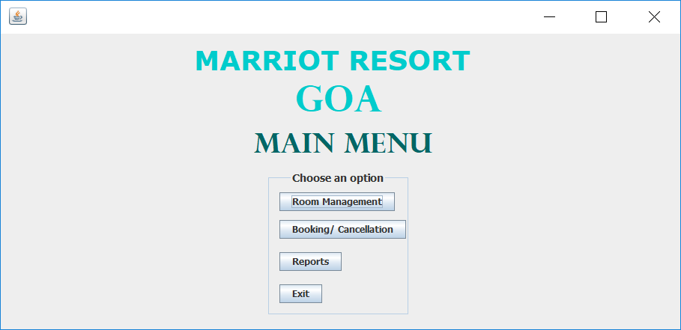

* **FRAME 2:**

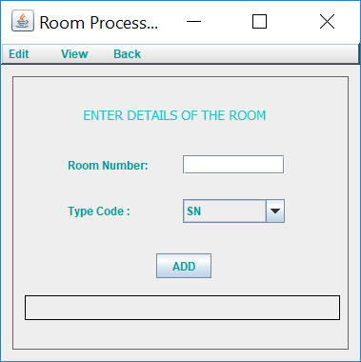

* **FRAME 3:**



* **FRAME 4:**

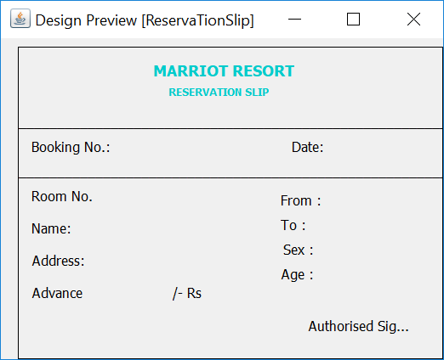

* **FRAME 5:**

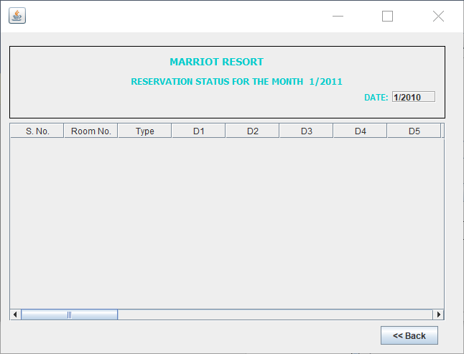

* **FRAME 6:**

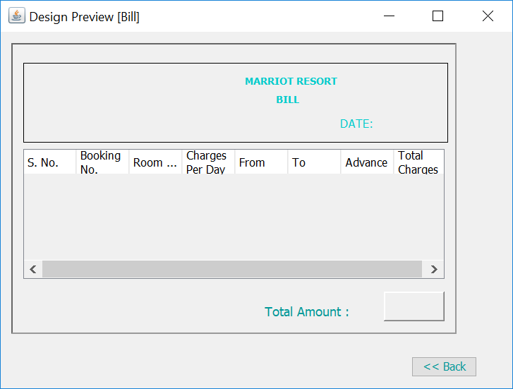

* **FRAME 7:**

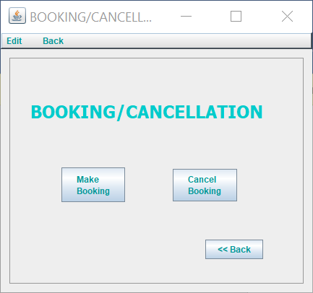

* **FRAME 8:**

